(1) Write a java program to find the sum of array elements.
(A)
public class SumOfArrays
{
public static void main(String ag[])
{
int a[] = {10,20,30,40,50};
int result = 0;
for(int index = 0;index <5;index++)
{
result = result+a[index];
}
System.out.println("result is ="+result);
}
}

OUTPUT :

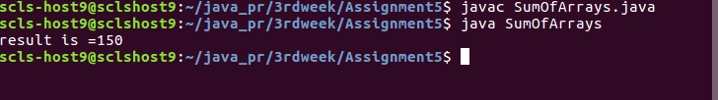

(2) Write a java program to print the elements of an array in the reverse order ?
(A)

public class ReverseOfArrays
{
public static void main(String ag[])
{
System.out.print("reverse order of array is = ");
int a[] = {10,20,30,40,50};
for(int index = 4;index >= 0;index--)
{
System.out.print(a[index]+", ");
}
}
}

OUTPUT :

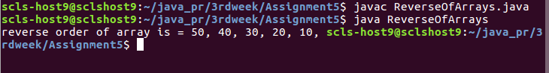

(3) Write a java program to find the biggest number in the given array ?
(A)

public class BiggestOfArray
{
public static void main(String ag[])
{
System.out.print("Biggest number in array is = ");
int a[] = {10,200,30,40,50};
int biggest = a[0];
for(int index = 0;index < 5;index++)
{
if(biggest < a[index])
{
biggest = a[index];
}

}
System.out.println(biggest);
}
}

OUTPUT :

